1. Carrier Delay

1. NAS Delay

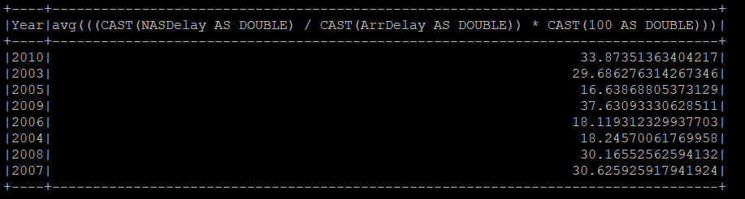

1. Weather Delay

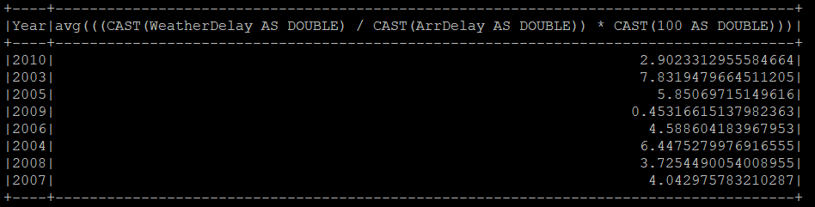

1. Late Aircraft Delay

1. Security Delay

